CHAPTER 5: Separating mixtures
Worksheet 5.7

Clean and clear?
Science Quest 7: pages 197–198
Student: Class:
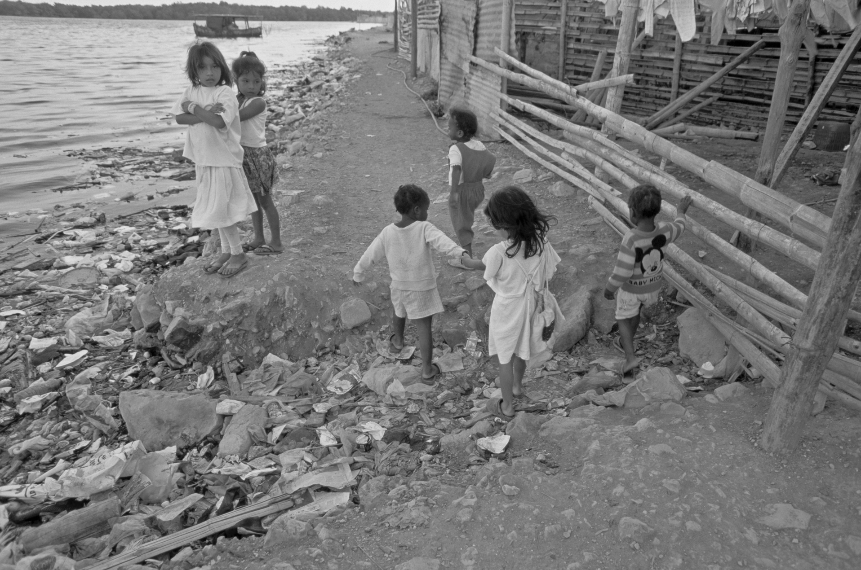
1. Consider the following piece of text.
Source: Corbis/Pablo Corral V

Dangerous water
Blackwater is a term given to water that contains chemical and biological contaminants (from faeces or toxic chemicals). Waterborne diseases are among the leading causes of death in developing countries. An estimated 2 million people die from water-related diarrhoea each year. At least 10 per cent of the total human diseases in many developing countries can be attributed to diarrhoea and
intestinal worms produced from microscopic eggs found in contaminated drinking water. Diarrhoea and vomiting can lead to extreme dehydration, shock and possibly death.
- Contaminated water is a major cause of death in children who live in developing countries.
Even in developed countries, water contamination is a problem. The US Environmental Protection Agency reports that 90 per cent of the world’s water is contaminated in some way. There is a variety of microscopic organisms that can contaminate water supplies and cause potentially serious, even fatal, illnesses among wilderness travellers.
Biologically contaminated water is water that contains micro-organisms such as giardia that, if not killed, lead to intestinal disorders. Toxic water contains chemical contamination from pesticide run-offs, mine tailings and so on.
(a) The table below lists a number of different techniques which allow mixtures to be separated. Use the information from the text to describe which water contaminants mentioned could be separated out by each technique.

Technique | Contaminant(s) removed
Filtration
Distillation
Decanting
Centrifuging
Flocculation

(b) Were there any contaminants that could not be separated out by any of these techniques? If so, what were they?

CHAPTER 5: Separating mixtures PAGE 2
Worksheet 5.7

2. Now consider this information:

To recycle or to not recycle
Greywater is wastewater generated from washing dishes, laundry and bathing in homes. It makes up 50–80 per cent of residential wastewater. Greywater does not contain chemical and biological contaminants. Greywater gets its name from its cloudy appearance and from its status as being neither fresh (whitewater from groundwater or taps) nor heavily polluted (blackwater).
If collected via a separate plumbing system, greywater can be recycled directly within the home and garden. Recycled greywater of this kind is never clean enough to drink, but a number of stages of filtration and microbial digestion can be used to provide water for washing or flushing toilets; relatively clean greywater may be applied directly from the sink to the garden, because it receives treatment from the soil and plant roots. Vegetables should not be watered with greywater.
On 26 July 2006, 61.62 per cent of Toowoomba’s residents opposed the treating of sewage for drinking water. Under the plan, wastewater would have been collected and put through a series of purifying treatments, including ultrafiltration, reverse osmosis and oxidation. The treated water would be pumped into a dam, where it would rest for three to five years — enough time to convince the community it is safe to drink.

(a) How does greywater differ from blackwater?

(b) What are the chief advantages of using greywater?

(c) Many people in Toowoomba opposed the treating of sewage for drinking water. Do you think it is a good idea? Give reasons for your answer.

(d) Why do you think vegetables should not be watered with greywater?

(e) What is whitewater?

